PACKING LIST
WODDEN DOORS
Quantity | Ref. | Type of Door | Sizes (cm) | Brand | Type Of Wood | Exemple of ref.
1 | R2P | Inside Door | 200x80 | Dimar | Mahogany | 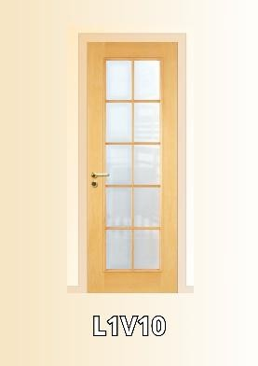  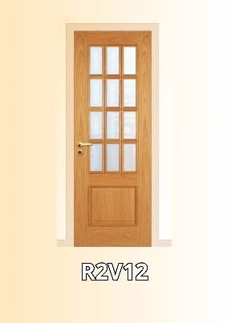
3 | L1 | Inside Door | 200x80 | Dimar | Mahogany
1 | L2V8 | Inside Door | 200x80 | Dimar | Oak
1 | R1E | Inside Door | 200x80 | Dimar | Mahogany
1 | L1E | Inside Door | 200x80 | Dimar | Mahogany
1 | R2P | Inside Door | 200x60 | Dimar | Mahogany
6 | R2EV8 | Inside Door | 200x65 | Dimar | Mahogany
10 | R2EV8 | Inside Door | 200x65 | Dimar | Mahogany
2 | L2V8 | Inside Door | 200x65 | Dimar | Mahogany
1 | R2V8 | Inside Door | 200x60 | Dimar | Mahogany
3 | L2V8 | Inside Door | 200x60 | Dimar | Mahogany
1 | L1 | Inside Door | 200x65 | Dimar | Tola Wood
2 | L2V8 | Inside Door | 200x60 | Dimar | Mahogany

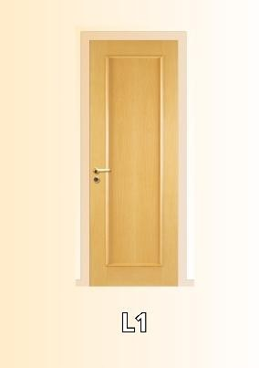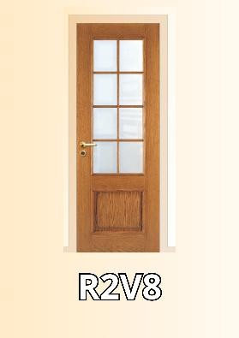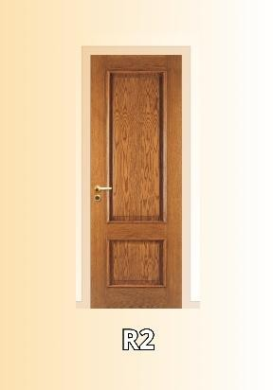
1 | L2V8 | Inside Door | 200x60 | Dimar | Mahogany
2 | L2V12 | Inside Door | 200x80 | Dimar | Mahogany
1 | L2V8 | Inside Door | 200x60 | Dimar | Mahogany
2 | PA12 | Inside Door | 200x75 | Porteme | Tola Wood
1 | R2EV8 | Inside Door | 200x70 | Dimar | Tola Wood
1 | R2 | Inside Door | 200x70 | Dimar | Tola Wood
1 | L1V1D | Inside Door | 200x70 | Dimar | Mahogany
1 | PA12 | Inside Door | 200x80 | Porteme | Mahogany
1 | R2EV12 | Inside Door | 200x95 | Dimar | Oak
1 | R2V8 | Inside Door | 200x65 | Dimar | Mahogany
1 | R2V12 | Inside Door | 200x75 | Dimar | Oak
1 | L1V15 | Inside Door | 200x75 | Dimar | Tola Wood
1 | R2 | Inside Door | 200x68 | Dimar | Beech
1 | R2 | Inside Door | 200x70 | Dimar | Tola Wood
1 | L1V1 | Inside Door | 200x75 | Dimar | Tola Wood
6 | L1V1 | Inside Door | 200x70 | Dimar | Beech
3 | R2EV8 | Inside Door | 200x60 | Dimar | Beech
1 | R2P | Inside Door | 200x80 | Dimar | Mahogany
1 | R2 | Inside Door | 200x60 | Dimar | Mahogany
1 | R2 | Inside Door | 200x65 | Dimar | Mahogany

4 | R2 | Inside Door | 200x60 | Dimar | Mahogany
2 | L1EV1 | Inside Door | 200x80 | Dimar | Mahogany
2 | R2 | Inside Door | 200x65 | Dimar | Mahogany
1 | PA12 | Inside Door | 200x65 | Porteme | Mahogany
1 | L2 | Inside Door | 180x75 | Dimar | Mahogany
1 | R2PV8 | Inside Door | 200x65 | Dimar | Mahogany
1 | R2PV8 | Inside Door | 200x65 | Dimar | Mahogany
1 | R2EV8 | Inside Door | 200x65 | Dimar | Mahogany
2 | R2P | Inside Door | 210x60 | Dimar | Mahogany
1 | L2 | Inside Door | 200x60 | Dimar | Mahogany
1 | L1 | Inside Door | 200x70 | Dimar | Brazilian Cherry Tree
1 | L2P | Inside Door | 210x70 | Dimar | Mahogany
1 | R2EV8 | Inside Door | 200x65 | Dimar | Mahogany
1 | R2EV12 | Inside Door | 200x80 | Dimar | Mahogany
1 | R2E | Inside Door | 190x65 | Dimar | Mahogany
2 | R2E | Inside Door | 200x60 | Dimar | Mahogany
2 | R2E | Inside Door | 200x60 | Dimar | Kambala
2 | R2E | Inside Door | 200x70 | Dimar | Mahogany
1 | L1V1 | Inside Door | 200x80 | Dimar | Mahogany
2 | R2EV8 | Inside Door | 200x75 | Dimar | Mahogany
1 | R2EV12 | Inside Door | 200x75 | Dimar | Mahogany
1 | L2V8 | Inside Door | 200x65 | Dimar | Mahogany
2 | R1E | Inside Door | 200x80 | Dimar | Mahogany
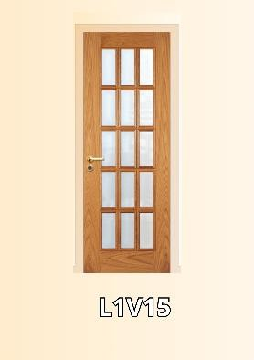
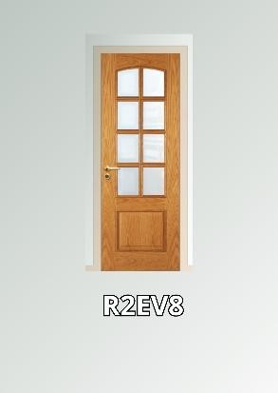
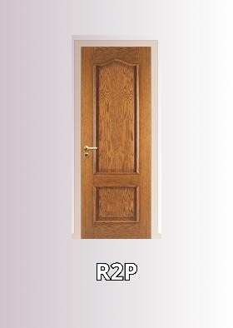

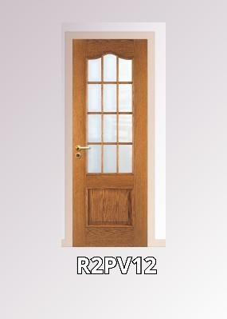
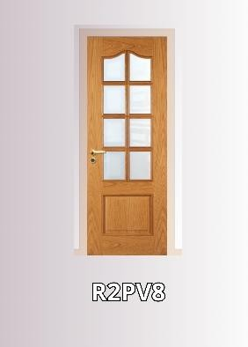
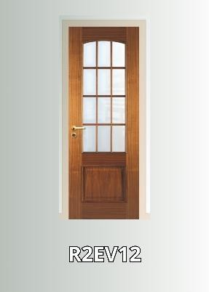
5 | R2EV12 | Inside Door | 200x65 | Dimar | Oak
1 | R2EV8 | Inside Door | 200x65 | Dimar | Mahogany
1 | R2EV8 | Inside Door | 200x65 | Dimar | Tola Wood
1 | L1V1 | Inside Door | 200x65 | Dimar | Oak
1 | R2EV12 | Inside Door | 200x75 | Dimar | Oak
1 | L2 | Inside Door | 190x80 | Dimar | Oak
1 | L2V12 | Inside Door | 200x75 | Dimar | Mahogany
1 | L2V9 | Inside Door | 200x75 | Dimar | Tola Wood
1 | L2V8 | Inside Door | 200x75 | Dimar | Tola Wood
1 | L2P | Inside Door | 200x70 | Dimar | Mahogany
1 | R2P | Inside Door | 200x70 | Dimar | Mahogany
1 | R2PV12 | Inside Door | 200x75 | Dimar | Tola Wood
1 | L1 | Inside Door | 200x75 | Dimar | Beech
1 | R2E | Inside Door | 200x70 | Dimar | Kambala
1 | L2 | Inside Door | 200x70 | Dimar | Beech
1 | R2EV12 | Inside Door | 200x75 | Dimar | Brazilian Cherry Tree
1 | R2V8 | Inside Door | 200x65 | Dimar | Brazilian Cherry Tree
1 | L1V12 | Inside Door | 200x60 | Dimar | Mahogany
1 | L2V12 | Inside Door | 200x65 | Dimar | Mahogany
8 | R2V8 | Inside Door | 200x65 | Dimar | Mahogany
1 | L1V10 | Inside Door | 200x70 | Dimar | Mahogany
1 | R2V8 | Inside Door | 200x60 | Dimar | Mahogany
1 | L1V10 | Inside Door | 200x65 | Dimar | Mahogany

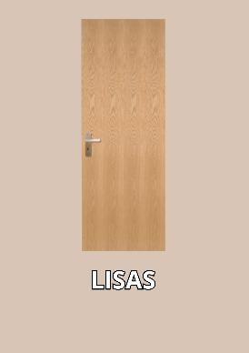
1 | L1PV10 | Inside Door | 200x60 | Dimar | Mahogany
2 | L1PV10 | Inside Door | 200x65 | Dimar | Mahogany
6 | L1V1 | Inside Door | 200x65 | Dimar | Mahogany
1 | L1V15 | Inside Door | 200x80 | Dimar | Mahogany
1 | L1EV12 | Inside Door | 200x80 | Dimar | Mahogany
2 | L1V10 | Inside Door | 200x65 | Dimar | Mahogany
6 | L1EV10 | Inside Door | 200x65 | Dimar | Mahogany
2 | R2 | Inside Door | 200x65 | Dimar | Mahogany
1 | R2P | Inside Door | 200x85 | Dimar | Mahogany
2 | R2P | Inside Door | 200x55 | Dimar | Mahogany
1 | R2V12 | Inside Door | 200x65 | Dimar | Brazilian Cherry Tree
1 | L2 | Inside Door | 200x65 | Dimar | Mahogany
4 | R2V8 | Inside Door | 200x60 | Dimar | Mahogany
1 | R2P | Inside Door | 200x55 | Dimar | Mahogany
1 | L2P | Inside Door | 200x75 | Dimar | Mahogany
1 | L2P | Inside Door | 200x70 | Dimar | Mahogany
1 | R2V8 | Inside Door | 200x75 | Dimar | Beech
1 | R2V8 | Inside Door | 200x65 | Dimar | Beech
1 | L2 | Inside Door | 200x75 | Dimar | Tola Wood
1 | L2P | Inside Door | 200x70 | Dimar | Tola Wood
1 | L2PV12 | Inside Door | 200x75 | Dimar | Tola Wood
2 | L1 | Inside Door | 200x80 | Dimar | Tola Wood
4 | R2E | Inside Door | 200x65 | Dimar | Mahogany

4 | R2V8 | Inside Door | 200x65 | Dimar | Oak
1 | R2PV12 | Inside Door | 200x75 | Dimar | Oak
2 | R2V8 | Inside Door | 200x75 | Dimar | Oak
2 | R2V8 | Inside Door | 200x90 | Dimar | Oak
1 | PA12 | Inside Door | 200x80 | Porteme | Oak
1 | R2PV12 | Inside Door | 200x85 | Dimar | Oak
2 | R2E | Inside Door | 200x60 | Dimar | Tola Wood
2 | R2EV8 | Inside Door | 200x70 | Dimar | Kambala
2 | R2E | Inside Door | 200x45 | Dimar | Tola Wood
1 | L2V8 | Inside Door | 200x85 | Dimar | Tola Wood
1 | L1V15 | Inside Door | 200x75 | Dimar | Tola Wood
1 | R2V8 | Inside Door | 200x85 | Dimar | Tola Wood
1 | RE2EV8 | Inside Door | 200x60 | Dimar | Tola Wood
1 | R2EV12 | Inside Door | 200x70 | Dimar | Tola Wood
2 | PA12 | Inside Door | 200x65 | Porteme | Mahogany
4 | PA8 | Inside Door | 200x60 | Porteme | Mahogany
1 | PA12 | Inside Door | 200x75 | Porteme | Tola Wood
17 | PA8 | Inside Door | 200x70 | Porteme | Tola Wood
2 | PA8 | Inside Door | 200x65 | Porteme | Tola Wood
18 | PA8 | Inside Door | 200x60 | Porteme | Tola Wood
24 | R2P | Inside Door | 200x80 | Dimar | Mahogany
1 | L2V8 | Inside Door | 200x80 | Dimar | Oak
4 | R2 | Inside Door | 200x80 | Dimar | Oak

2 | R2 | Inside Door | 200x75 | Dimar | Mahogany
3 | R2 | Inside Door | 200x90 | Dimar | Mahogany
16 | 2 alm. Bites | Inside Door | 200x60 | Porteme | Mahogany
25 | 2 alm. Bites | Inside Door | 200x80 | Porteme | Mahogany
20 | 2 alm. Bites | Inside Door | 200x65 | Porteme | Mahogany
2 | 2 alm. Bites | Inside Door | 200x70 | Porteme | Mahogany
42 | 2 alm. Bites | Inside Door | 200x75 | Porteme | Mahogany
4 | 2 alm. Bites | Inside Door | 200x60 | Porteme | Mahogany
30 | 2 alm. Bites | wardrobe Door | 180x50 | Porteme | Mahogany
12 | 2 alm. Bites | wardrobe Door | 180x60 | Porteme | Mahogany
42 | 2 alm. Bites | wardrobe Door | 180x45 | Porteme | Mahogany
30 | 1 alm. Bites | Small Wardrope door | 50x50 | Porteme | Mahogany
60 | L1 | Small Wardrope door | many sizes | Dimar | Mahogany
130 | R1E | Small Wardrope door | 50x40 | Dimar | Mahogany
4 | L2 | wardrobe Door | 180x50 | Dimar | Mahogany
4 | L2 | wardrobe Door | 180x60 | Dimar | Mahogany
20 | R2P | wardrobe Door | 180x45 | Dimar | Mahogany
20 | R2P | wardrobe Door | 180x50 | Dimar | Mahogany
5 | R2E | wardrobe Door | 180x55 | Dimar | Mahogany
32 | 1Alm. Bites | wardrobe Door | 180x45 | Porteme | Mahogany
58 | Lisas | Inside Door | 200x65 | Porteme | Tola Wood
27 | Lisas | Inside Door | 200x65 | Porteme | Kambala
8 | Lisas | Inside Door | 200x60 | Porteme | Kambala

42 | Lisas | Inside Door | 200x60 | Porteme | Oak
44 | Lisas | Inside Door | 200x60 | Porteme | Pine
10 | Lisas | Inside Door | 200x65 | Porteme | Pine
15 | Lisas22mm | wardrobe Door | 200x55 | Porteme | Oak
6 | Lisas22mm | wardrobe Door | 200x50 | Porteme | Oak
5 | Lisas22mm | wardrobe Door | 200x65 | Porteme | Pine
17 | Lisas29mm | wardrobe Door | 200x100 | Porteme | Pine
8 | Lisas29mm | wardrobe Door | 200x80 | Porteme | Pine
8 | Lisas29mm | wardrobe Door | 200x90 | Porteme | Pine
15 | Lisas29mm | wardrobe Door | 200x45 | Porteme | Pine
13 | Lisas29mm | wardrobe Door | 200x55 | Porteme | Mahogany
47 | Lisas29mm | wardrobe Door | 200x50 | Porteme | Mahogany
77 | Lisas29mm | wardrobe Door | 200x45 | Porteme | Mahogany
32 | Lisas29mm | wardrobe Door | 200x40 | Porteme | Mahogany
25 | Lisas | Inside Door | 200x75 | Porteme | Blatex
1229

